Opoz 8000

The Opoz 8000 series offers a highly integrated point-of-sale system specifically designed for restaurants, fashion shops and department stores. With a simple, unique shape and modularized design, this system provides a flexible assembly for different applications. The soothing Acrylic finish, show on high quality.
- Detachable and cable hidden design, host unit can be mounted under the table, make you a clean work environment
- The high compact monitor can built include with Keyboard, MSR, Pole display and Touch Module, compliance with Ergonomics design. Provide an excellent inter-communication platform.
- Profuse interfaces enable you to connect with all kinds of POS peripheral equipments.

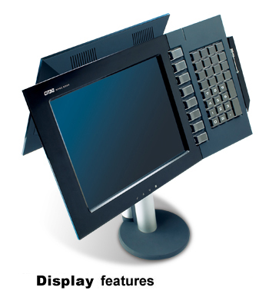
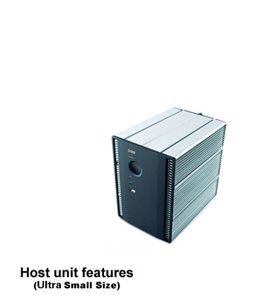

Host
CPU | Intel Celeron-M 1.5GHz, 1M cache
RAM | DDR2 1GB on board (Up to 2GB)
HDD | 160G 2.5" SATA HDD
Monitor
Monitor | 12" or 15" TFT LCD (1024 X 768)
Touch Panel | ELD 5 wire resistive touch screen, water-spill proof,  4096 x 4096, 35 million touches (optional).
Interface
Serial Port | 3 x external RS232, 1 x external RS485
Parallel Port | 1 x external
Powered USB | 2 x external(12V), 1 x external(24V)
USB2.0 | 1 x front, 2 x rear
VGA | 1 x external
LVDS | 1 x external (for Second Monitor)
LAN | 1 x 10M/100M Ethernet
PS/2 | 1 x external (for Keyboard)
12V Output | 1 x external (for Monitor)
PCI | 1 x internal
Mouse | by USB
Option
Customer Display | 2 x 20 (5 x 7) Dot Matrix VFD.  Combined on the host or stand alone pole display.
Second Monitor | 12" TFT LCD (1024 x 768)
MSR | Support 1-2-3 tracks
Laser Scanner | Share Pole with Main Monitor or Stand Alone with Short Pole
Printer | Opoz RP-5080 80mm high speed thermal printer.
Cash Drawer | CR-3040
Dimension
Host | 235(L) X 156(W) X 212(H)mm
12" Monitor with VFD Display | 460(L) X 290(W) X 510(H)mm
15" Monitor with Daul Display | 385(L) X 310(W) X 430(H)mm

