1. How to use my VPN in Ubuntu 14.04 LTS ?
1.1. Click upper right corner Network --> VPN Connections --> Configure VPN
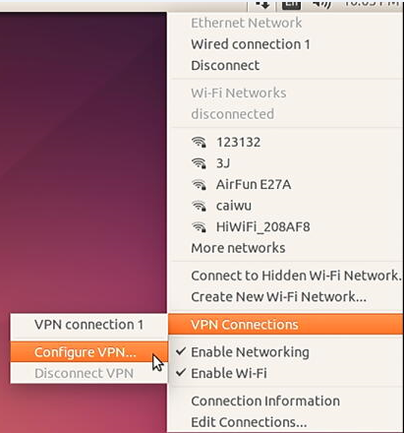
1.2. Then will pop up below picture shows and Click Add
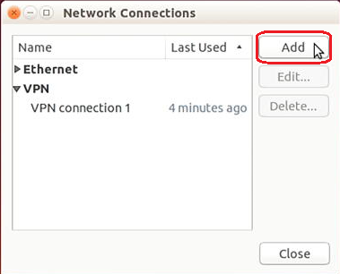
1.3. Choose a connection type, select Point-to Point tunnelling Protocol(PPTP)
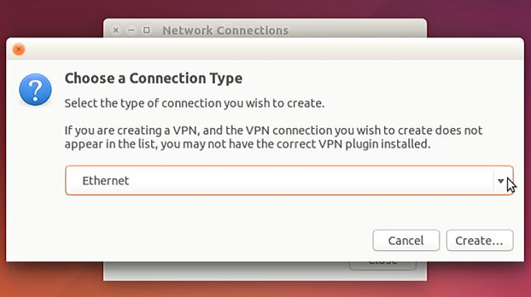

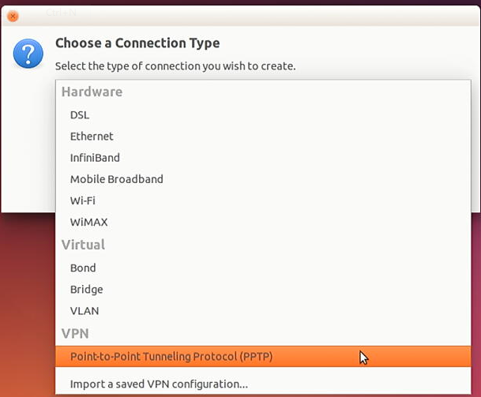
1.4. Then click Create
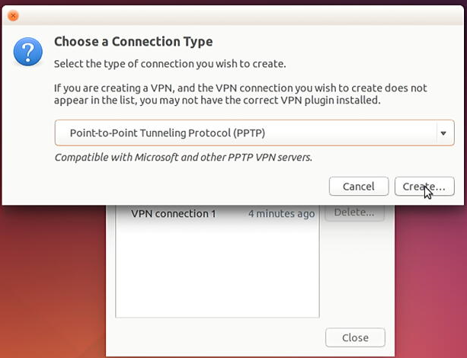
1.5. Then select VPN --> fill in Connection name as you like--> fill in Gateway --> User name --> Password -->then click Advance
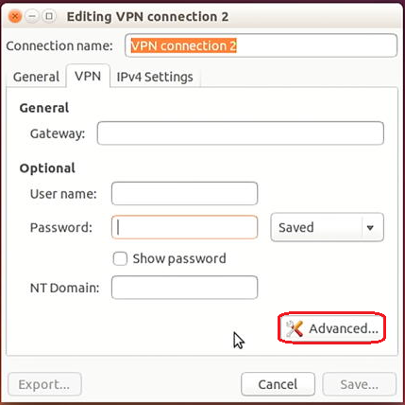
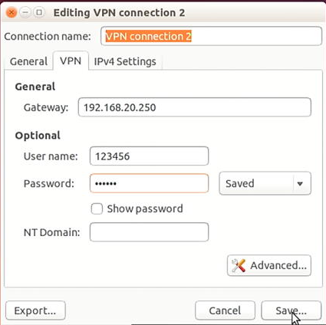
1.6. Tick Use Point-to-Point encryption(MPPE) --> OK --> then Save
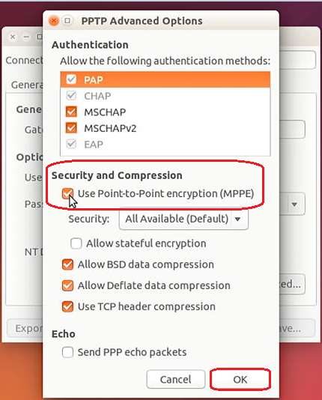
1.7. Click upper right corner Network --> VPN Connections --> select the connection you created(eg. VPN connection 1).
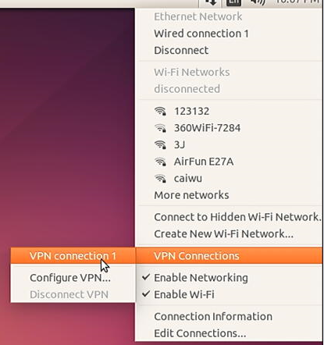

1.8. Finally you will see below picture, it shows VPN Login Message VPN connection has been successfully established.
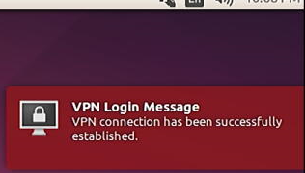

- How can I know my Ubuntu Gateway?
2.1. Press the combination key “Ctrl + Alt + t” to pop up dialog box
2.2. Key in: sudo route -n
Then will ask for password (the Ubuntu login account password)
2.3. Key in your password
Then will see Gateway message (e.g. Below picture gateway: 192.168.20.250)
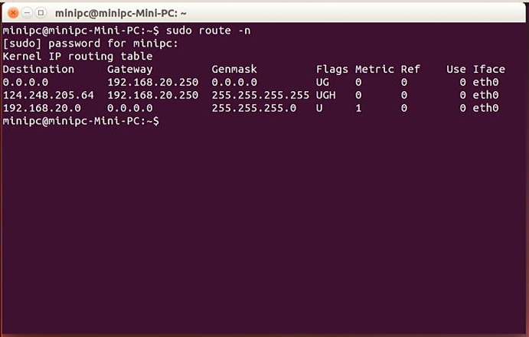
3. How to install Ubuntu system ?
3.1. Firstly connect to TV set with HDMI cable, TV sets HDMI as input source;
USB disk with Ubuntu installation package plugin the Mini PC;
USB Mouse and USB keyboard are also connected to the Mini PC;
In order to speed up the process of the installing Ubuntu system, do not connect to the internet with LAN cable.
3.2. Power on the Mini PC, press the power button for about 2 seconds to Start up the Mini PC, the LED light turns from red to blue (if it is Mini PC box -- in the front panel, if it is the PC stick, at the larger side of the outermost shell) and we will see the BIOS Logo such as: V2.90
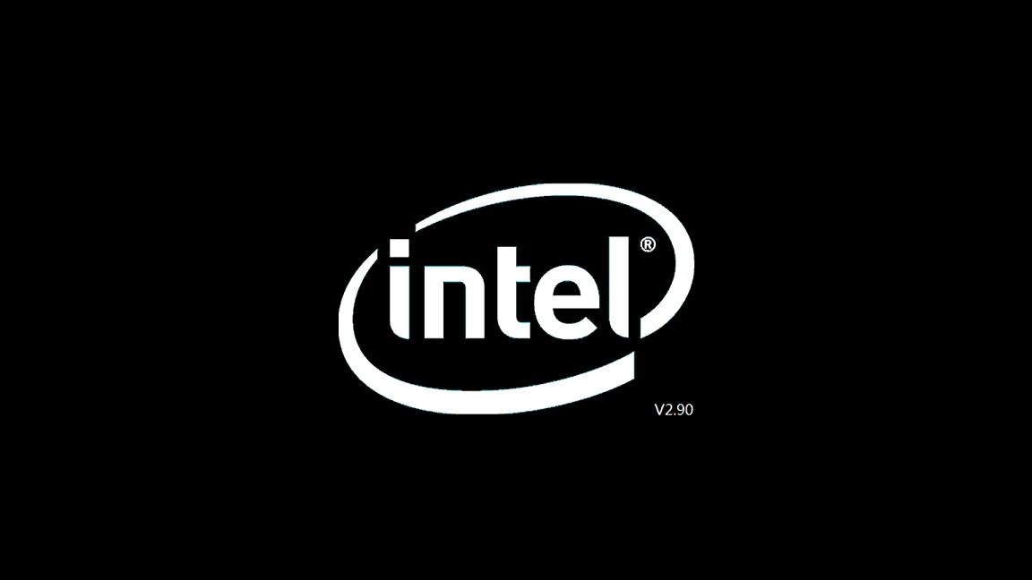
and press F7 key on keyboard continuously until we can see the picture below, and elect the USB with Ubuntu installation package (UEFI: KingstonDT Ult image G3 PMAP, Partition 1--contain Ubuntu installation package);
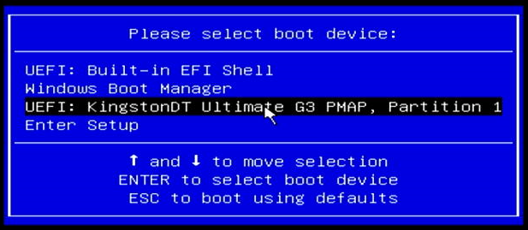
3.3. Then we will see below picture and select *Install Ubuntu and press “Enter” in Keyboard.
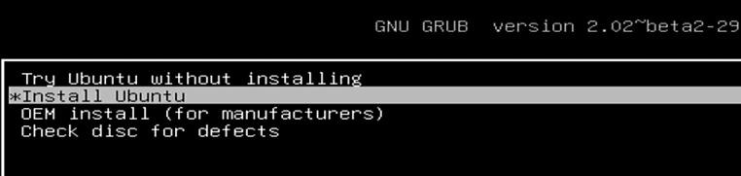

3.4. After showing a short time of this picture:
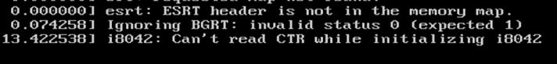
We will see Ubuntu logo shows as below:
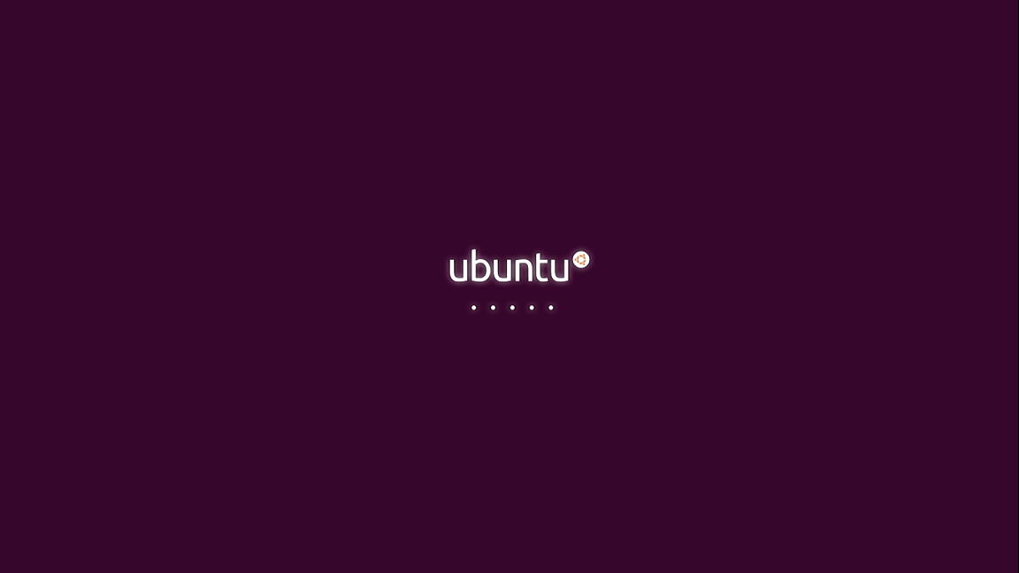

3.5. Select the language:
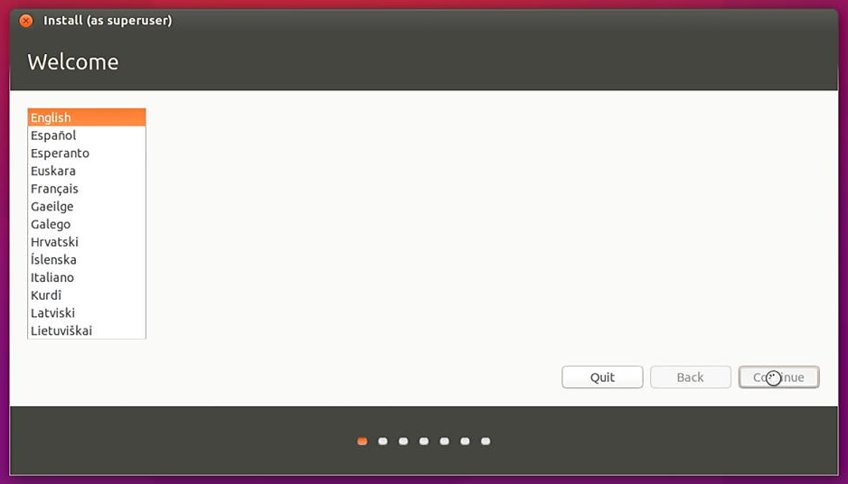

3.6. Preparing to install Ubuntu (has at least 6.9GB available drive space) and press continue:
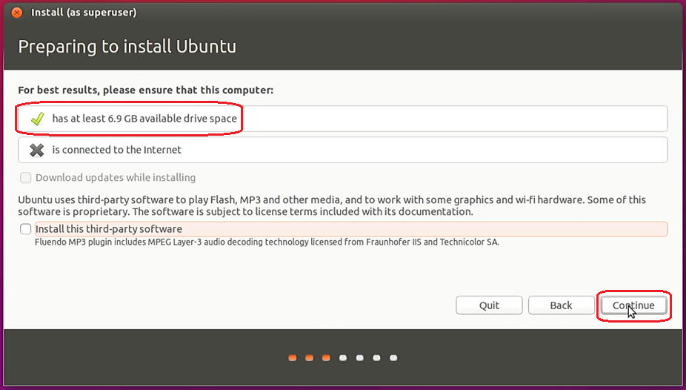
3.7. Installation type: if you had already installed the Ubuntu system or you wish change the windows system to Ubuntu system, you might see below selections:
3.7.1.Erase Ubuntu15.10 and install Warning: this will delete all your Ubuntu 15.10 programs, photos, music, and any other files.
3.7.2. Install Ubuntu 15.10 alongside Window 10 ( you will have 2 Operating Systems：one for Win10 OS and one for Ubuntu system) Document, music, and other personal files will be kept. You can choose witch operating system you want each time the computer starts up.
3.7.3. Install Ubuntu 15.10 alongside Ubuntu15.10 ( you will have 2 Ubuntu systems) Document, music, and other personal files will be kept. You can choose witch operating system you want each time the computer starts up.
3.7.4. Erase disk and install Ubuntu (single Ubuntu system ) Warning: this will delete all your programs, documents, photos, music, and any other files in all operating systems.
3.7.5. Encrypt the new Ubuntu installation for security
3.7.6. Use LVM with the new Ubuntu installation
3.7.7. Something else
We will select the 3.8.4., and press Install Now.
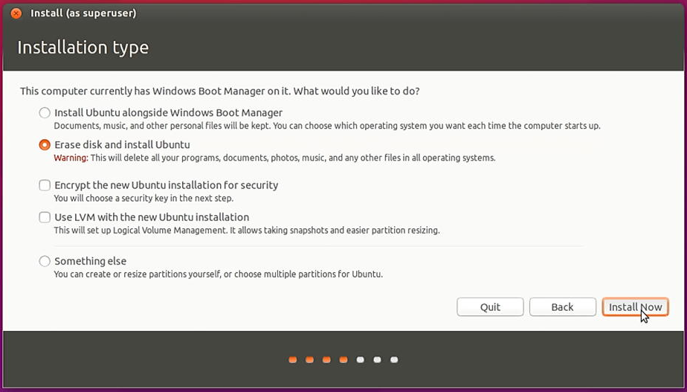
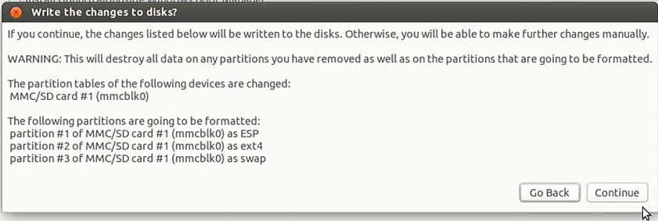
3.8. Select your location:
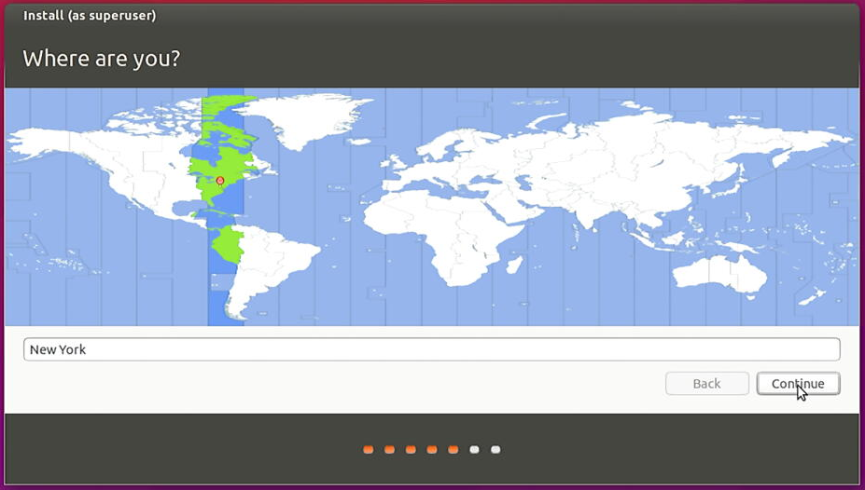

3.9. Keyboard layout:
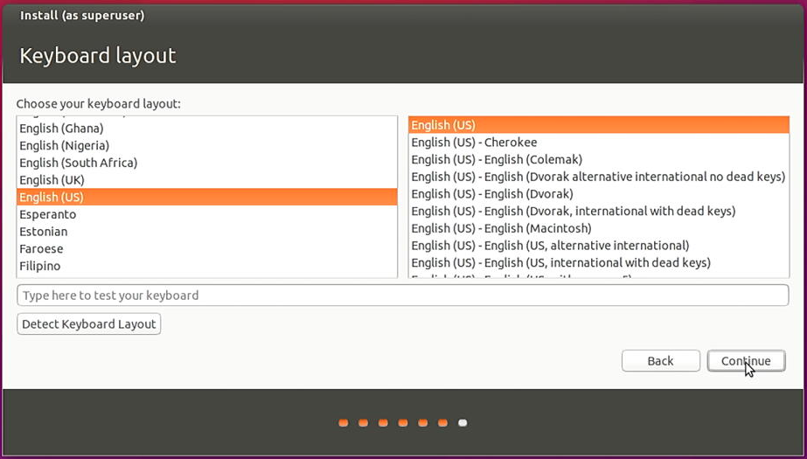
3.10. Set up your name and password (if you don’t want to input password, just select Log in automatically):
And then press Continue
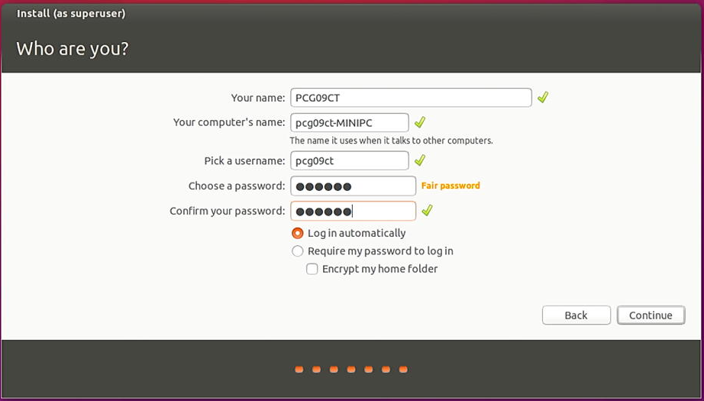
3.11. Installing continues, until completed; at the end, press Restart Now.
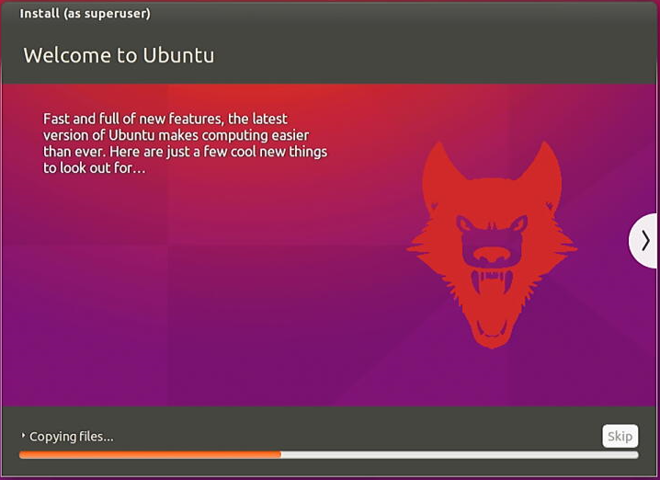
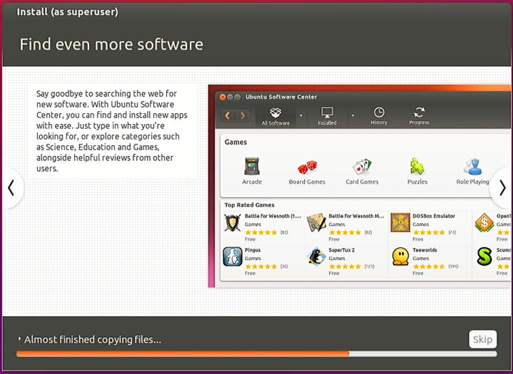
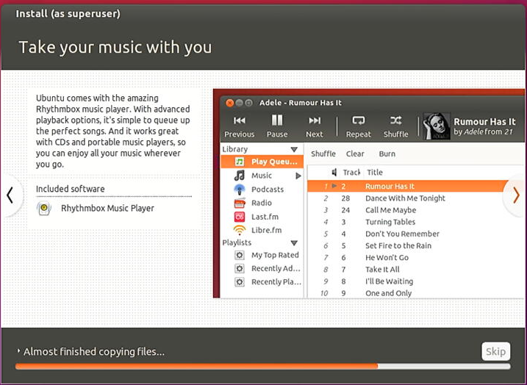
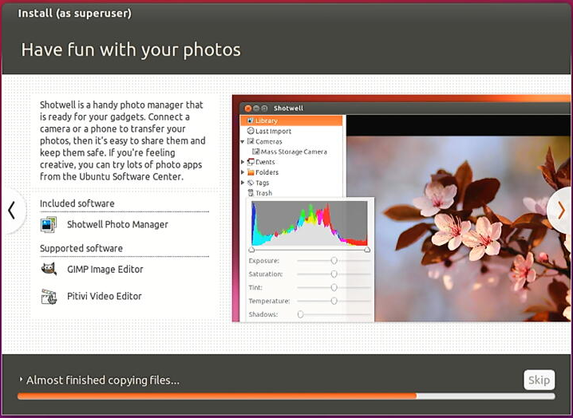
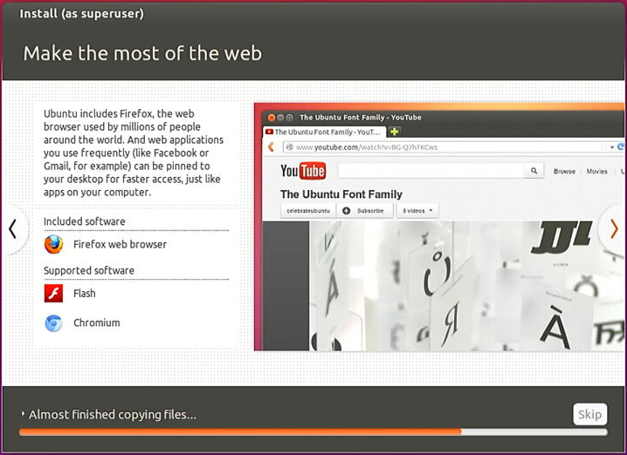
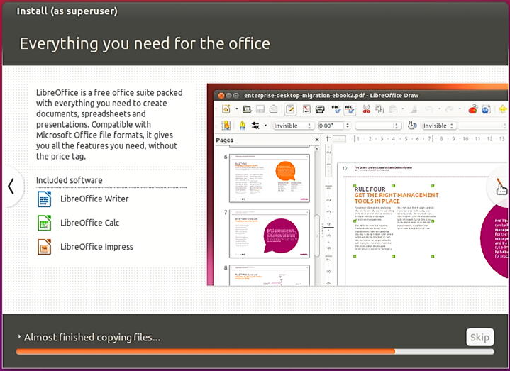
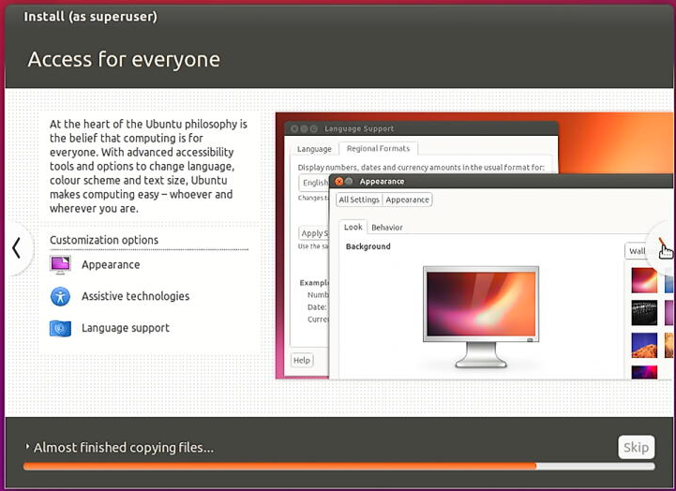
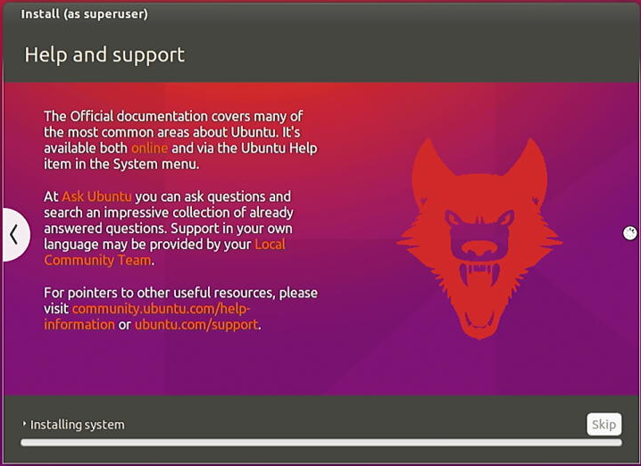
When Seeing the below picture, you can click “Restart Now”.
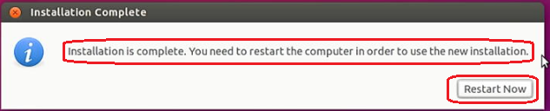
4. How to adjust the resolution of video output via HDMI to HDTV?
4.1. Click mouse left key at top right corner of Ubuntu account and choose “System settings...”
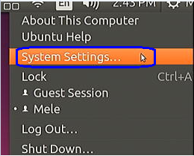
4.2. Click "Displays".
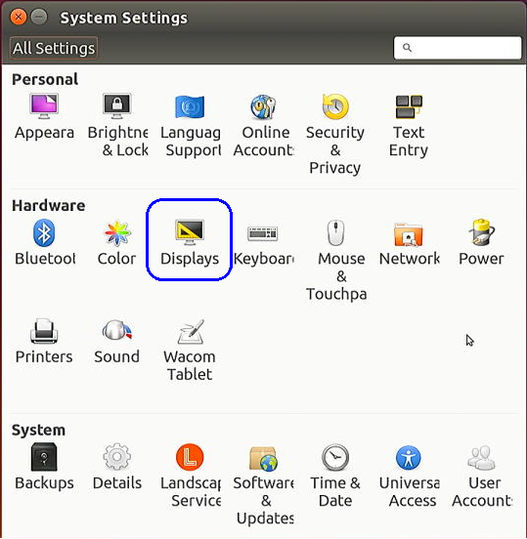
4.2. Select the correct “Resolution” to adjust to correct display on TV.
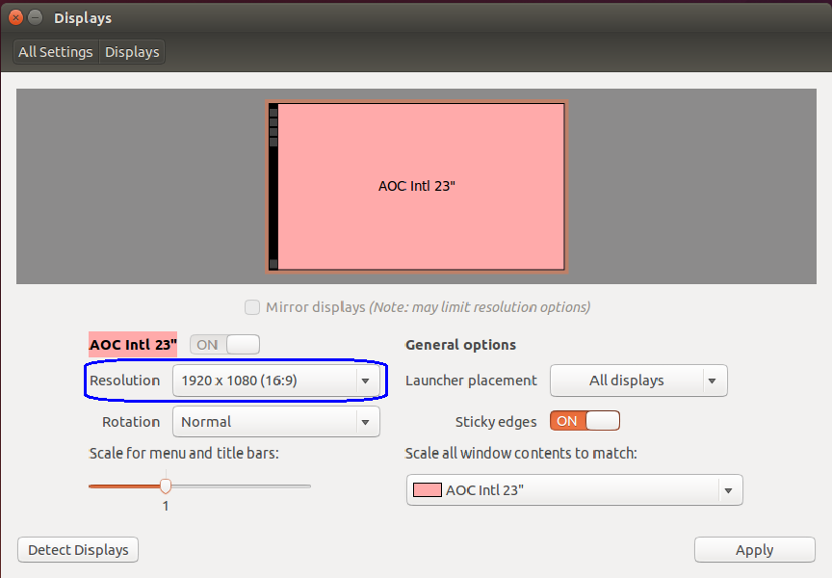
5. How to adjust the sound volume?
5.1. Click mouse left key at top right corner of Ubuntu account and choose "System settings..."
5.2. Click "Sound".
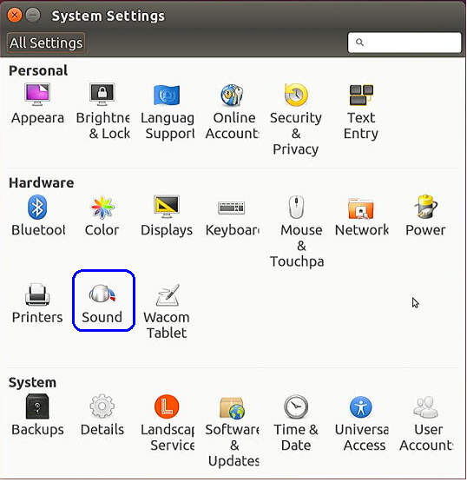
5.3. Adjust the "Output volume".
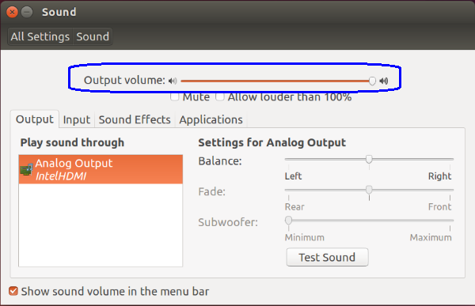
6. How to update MPEG Decoding library:
6.1. Firstly power on the mini PC and enter Ubuntu system --> connect to the internet via WiFi or LAN from USB (LAN would be much faster than WiFi), --> click mouse left key at top right corner of Ubuntu account and choose "System settings..."
6.2. Click software & update
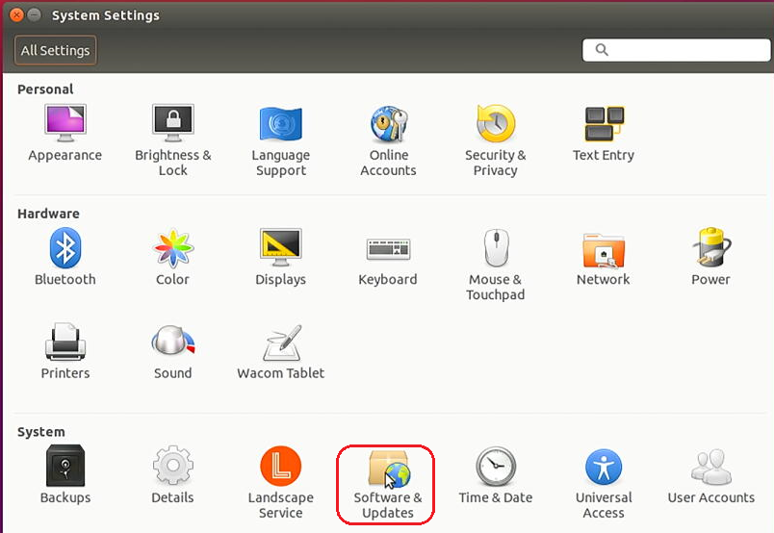
6.3. Select all options in all selections e.g. Ubuntu Software, Other Software, Updates.
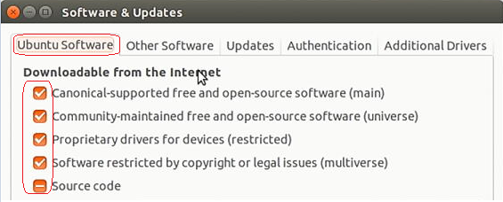
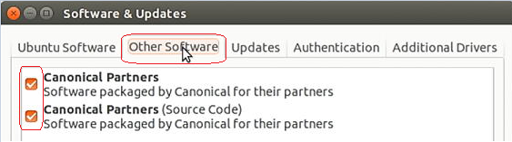
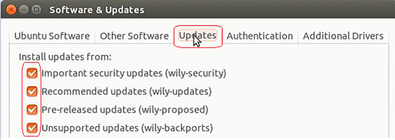

6.4.During this process, the Ubuntu will ask to input system account password for authorization, and please input your password to proceed, then click “Authenticate”.
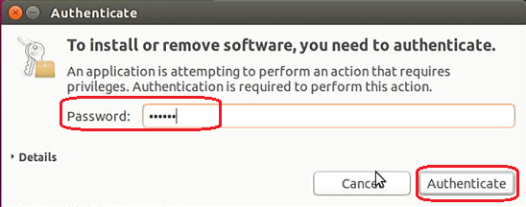
6.5. We will need to select the server to download as below shows, usually we select Other...
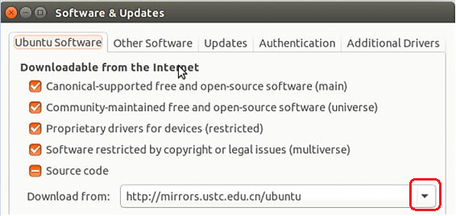
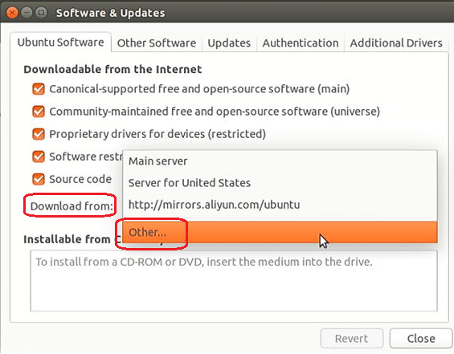
6.6. Choose a Download Server , we click “Select Best Server” shown as below:
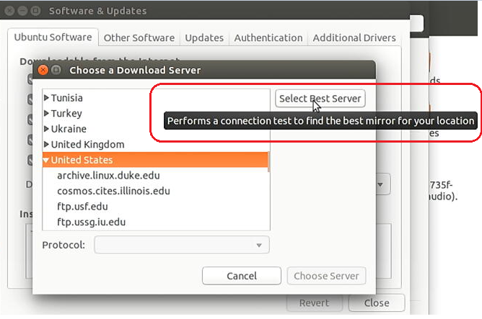
6.7. Click “Close”, it will start downloading.
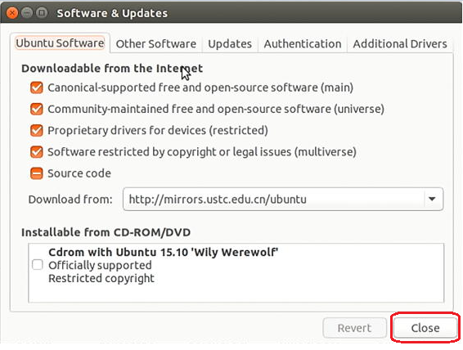
6.8. If you click Detail above, it will show the downloading detail information as below: 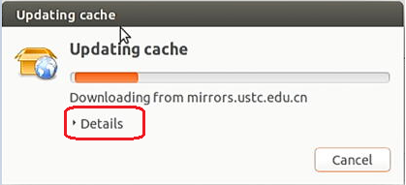
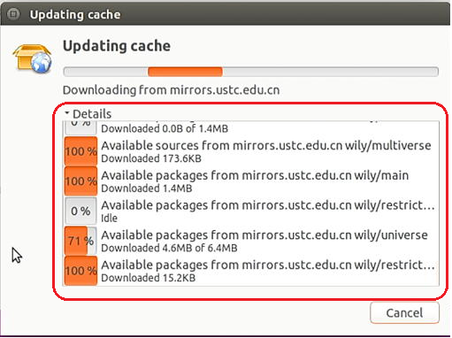
6.9. After finishing downloading (timing depends on the LAN speed), press 3 keys “Ctrl + Alt + t ” at the same time, and type sudo apt-get upgrade -->Enter --> then input password.
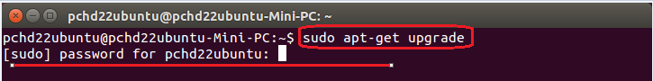
6.10. Ubuntu will start upgrading, and then will ask you:
After this operation, 12.0 MB of additional disk space will be used. Do you want to continue? [Y/n], please type y and press Enter
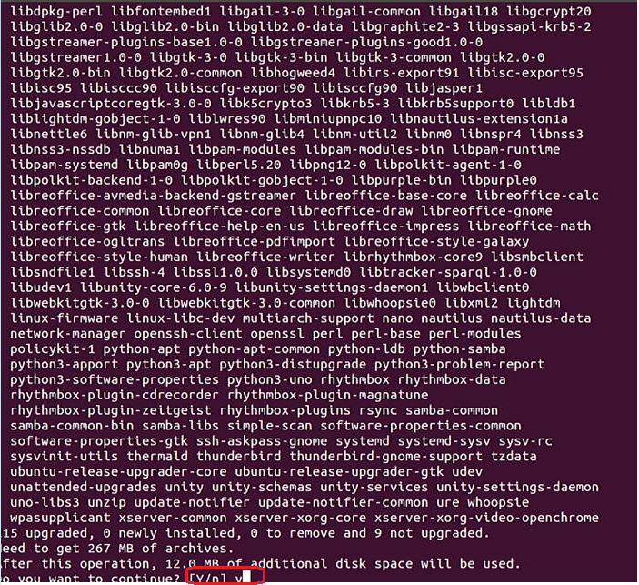
6.11. When finished, it will show many done --> type exit to exit the dialog --> restart Ubuntu.
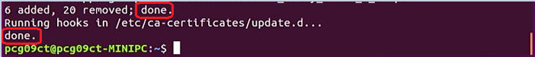
6.12. For the 1st time we playing the video file, it will auto pop up dialog box : Searching for multimedia plugins.
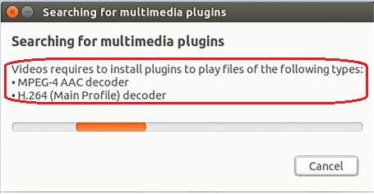
6.13. Then select all the options (e.g. Below picture: gstreamer1.0-libav / gstreamer1.0-pllugins-bad-faad / gstreamer1.0-plugins-bad-videoparsers) --> then Install.
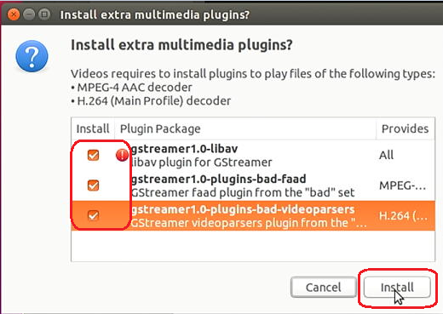
6.14. Session-installer --> press Continue
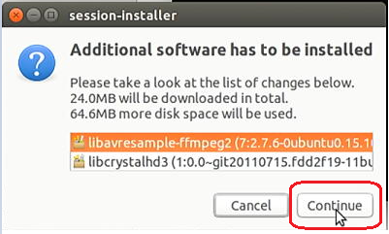
6.15. Then we can watch anything we want from HDMI both video and sound.

7. How to check my Mac address (Hardware address) ?
7.1. Firstly power on the mini PC and enter Ubuntu system --> click mouse left key at top right corner of Ubuntu account and choose "System settings..."
7.2. Double click Network --> Wired --> then we could see the Mac address (Hardware address).
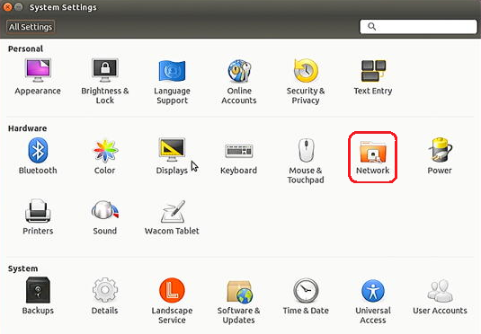
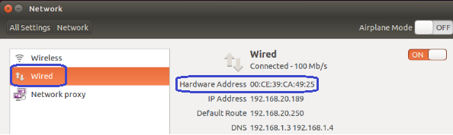
8. How to change User Accounts ?
8.1. Firstly power on the mini PC and enter Ubuntu system --> click mouse left key at top right corner of Ubuntu account and choose "System settings..."
8.2. Double click User Accounts --> Unlock.
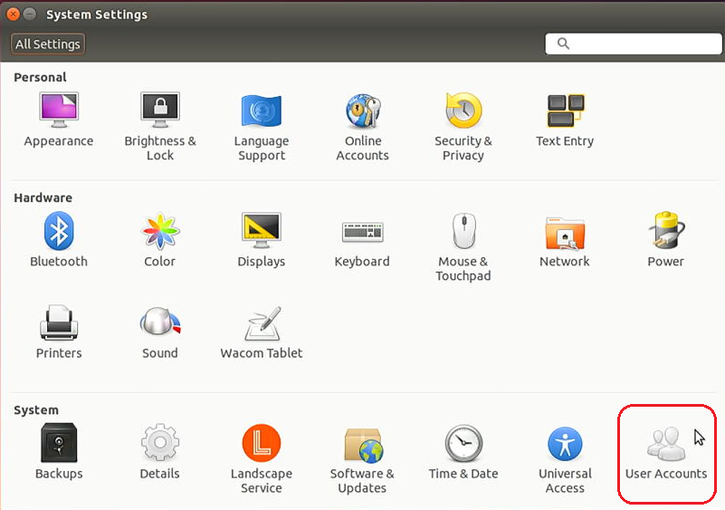
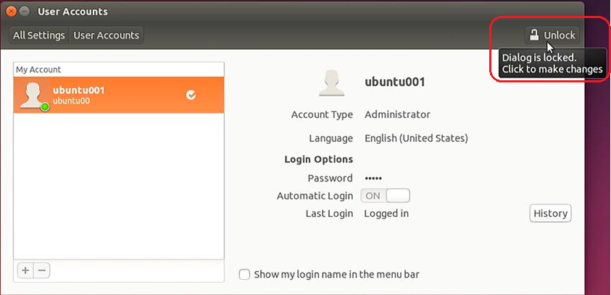
8.3. Input password --> Authenticate
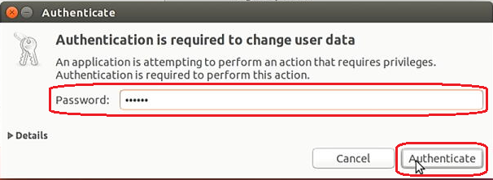
8.4. Input new User Accounts on the right hand side e.g. PCHD23ubuntu ( On the left hand side My Account is the previous Accounts ubuntu001) --> then click Lock
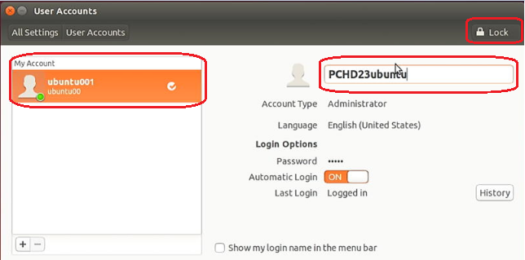
8.5. Now click mouse left key at top right corner of Ubuntu account, we can see the User Accounts has changed to the PCHD23ubuntu. (the previous Accounts ubuntu001).
